CLOUD COMPUTING
LAB 2
MONOLITHIC ARCHITECTURE

NAME: Asmi Vishal Kapadnis
SRN: PES2UG23CS100
SECTION: B

SCREENSHOTS:
SS1:
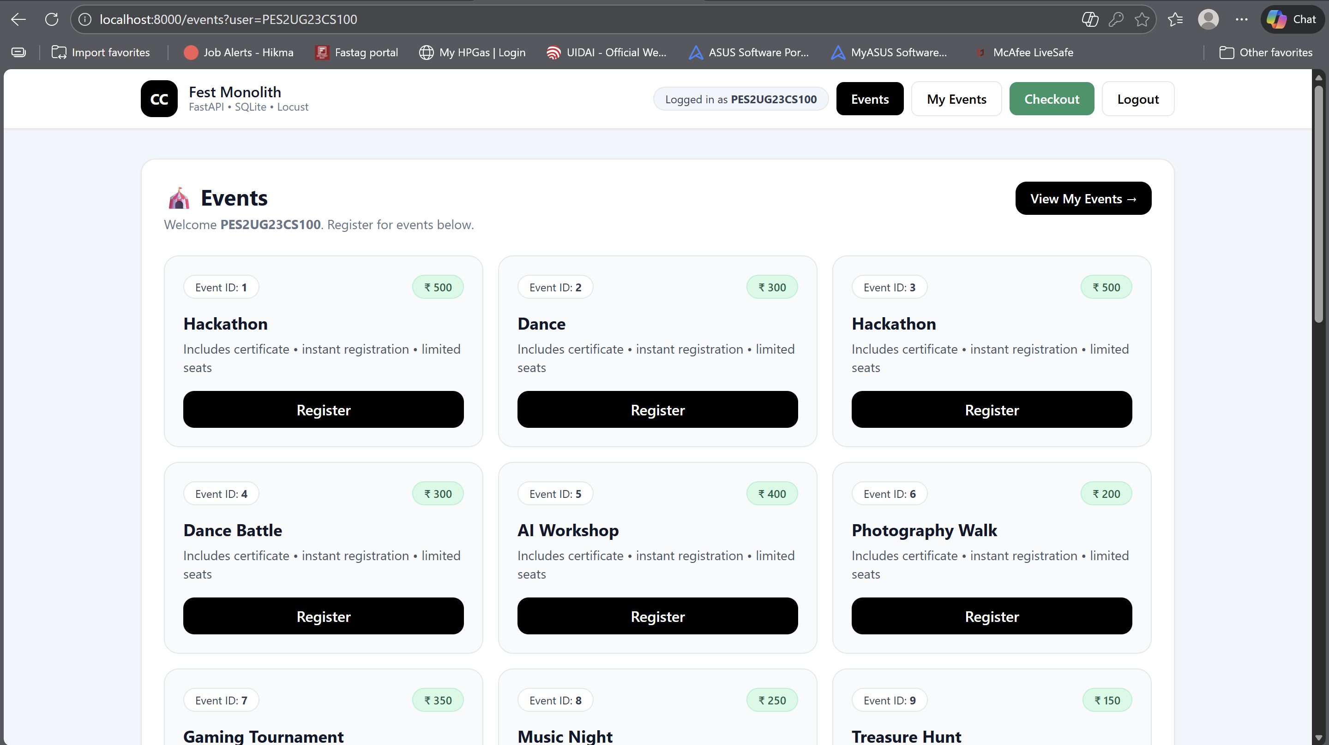

SS2:
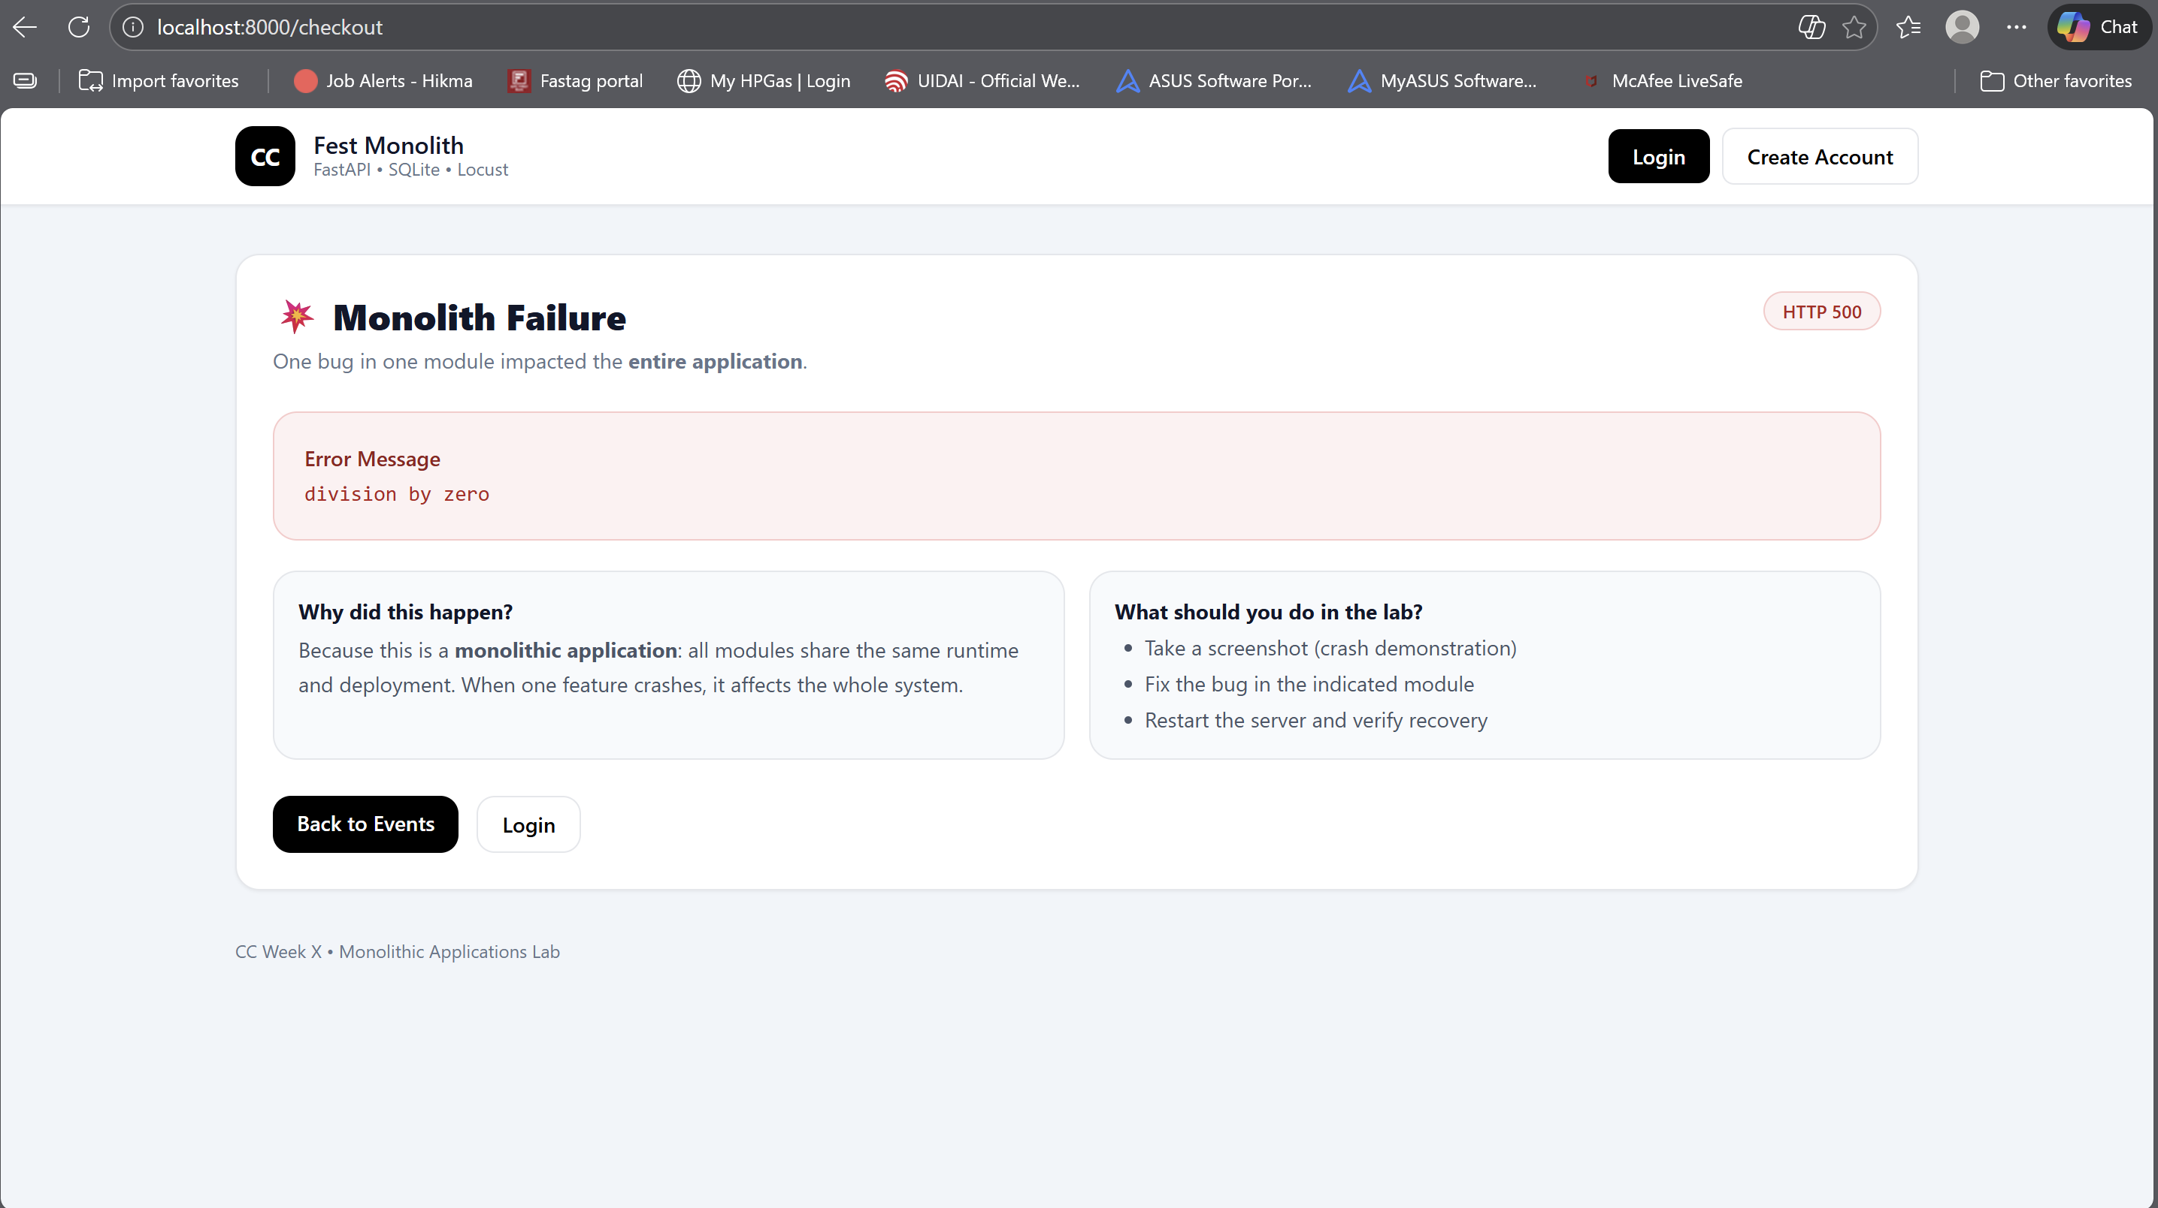

SS3:
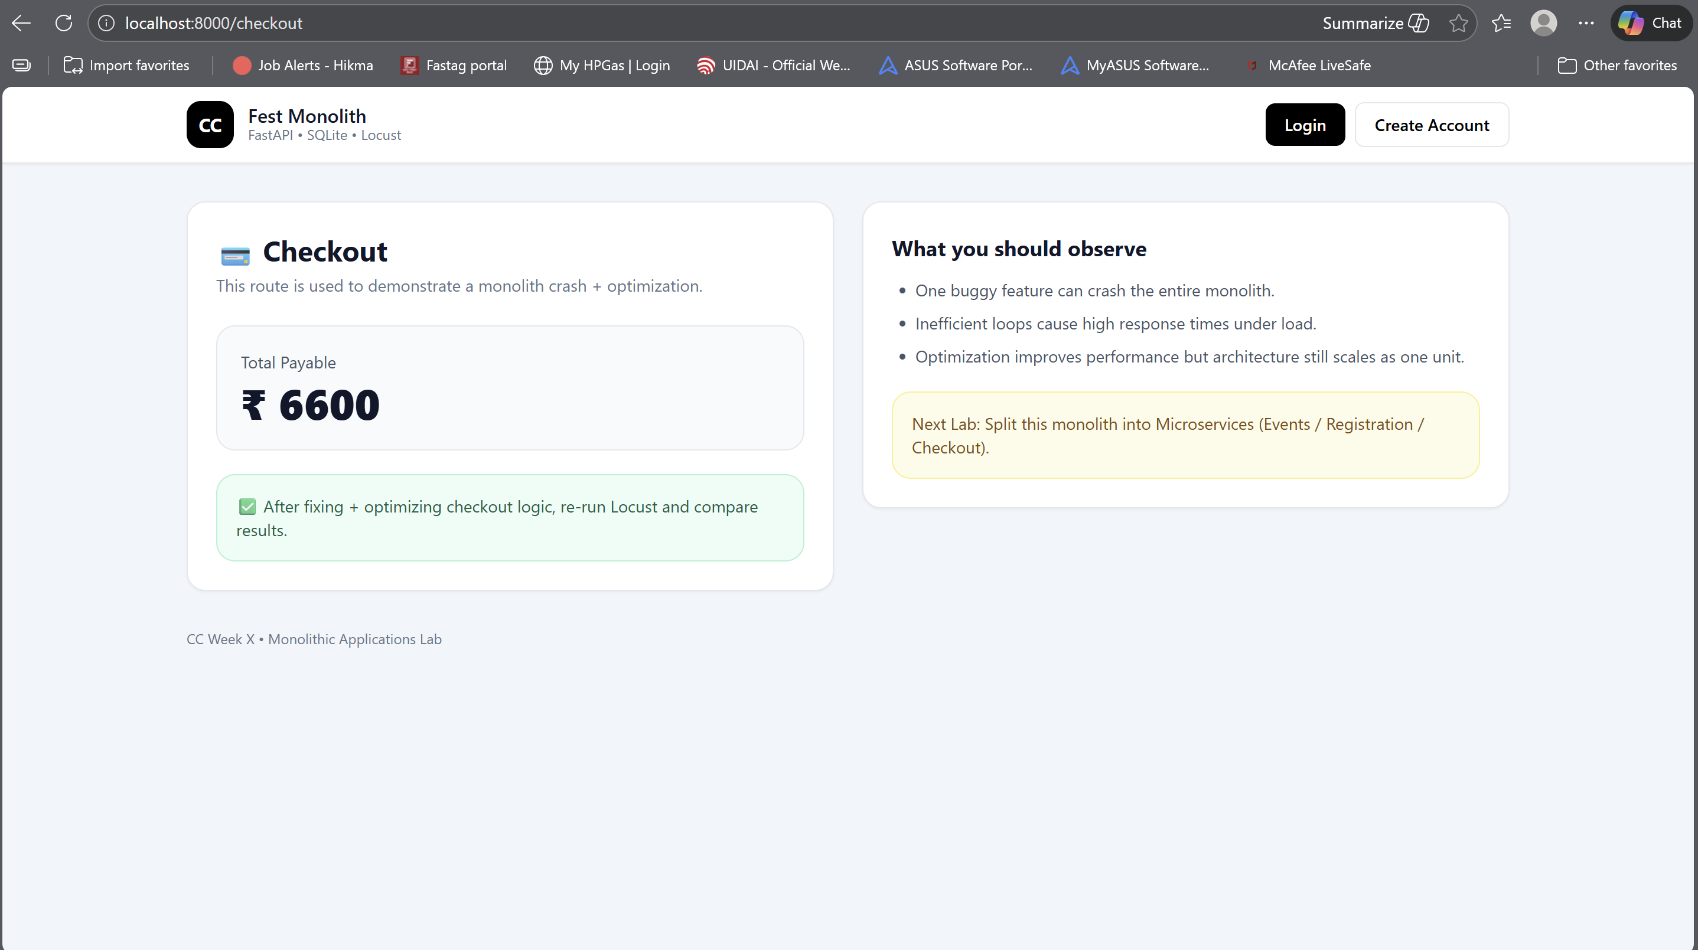

SS4:
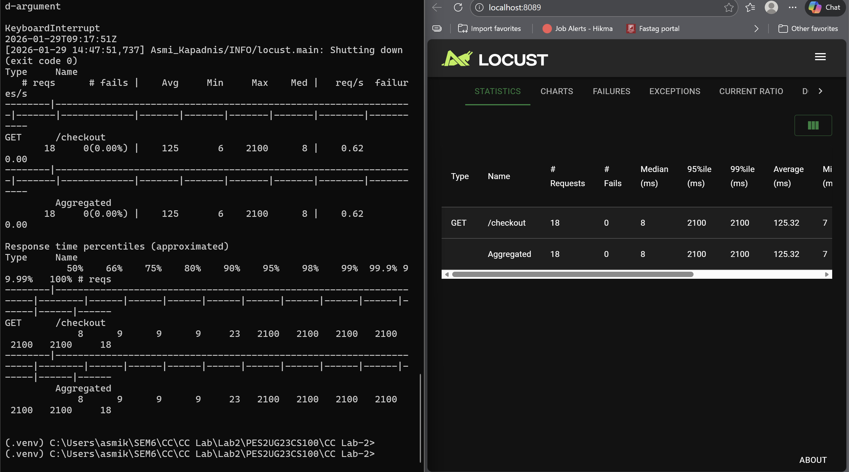

SS5:
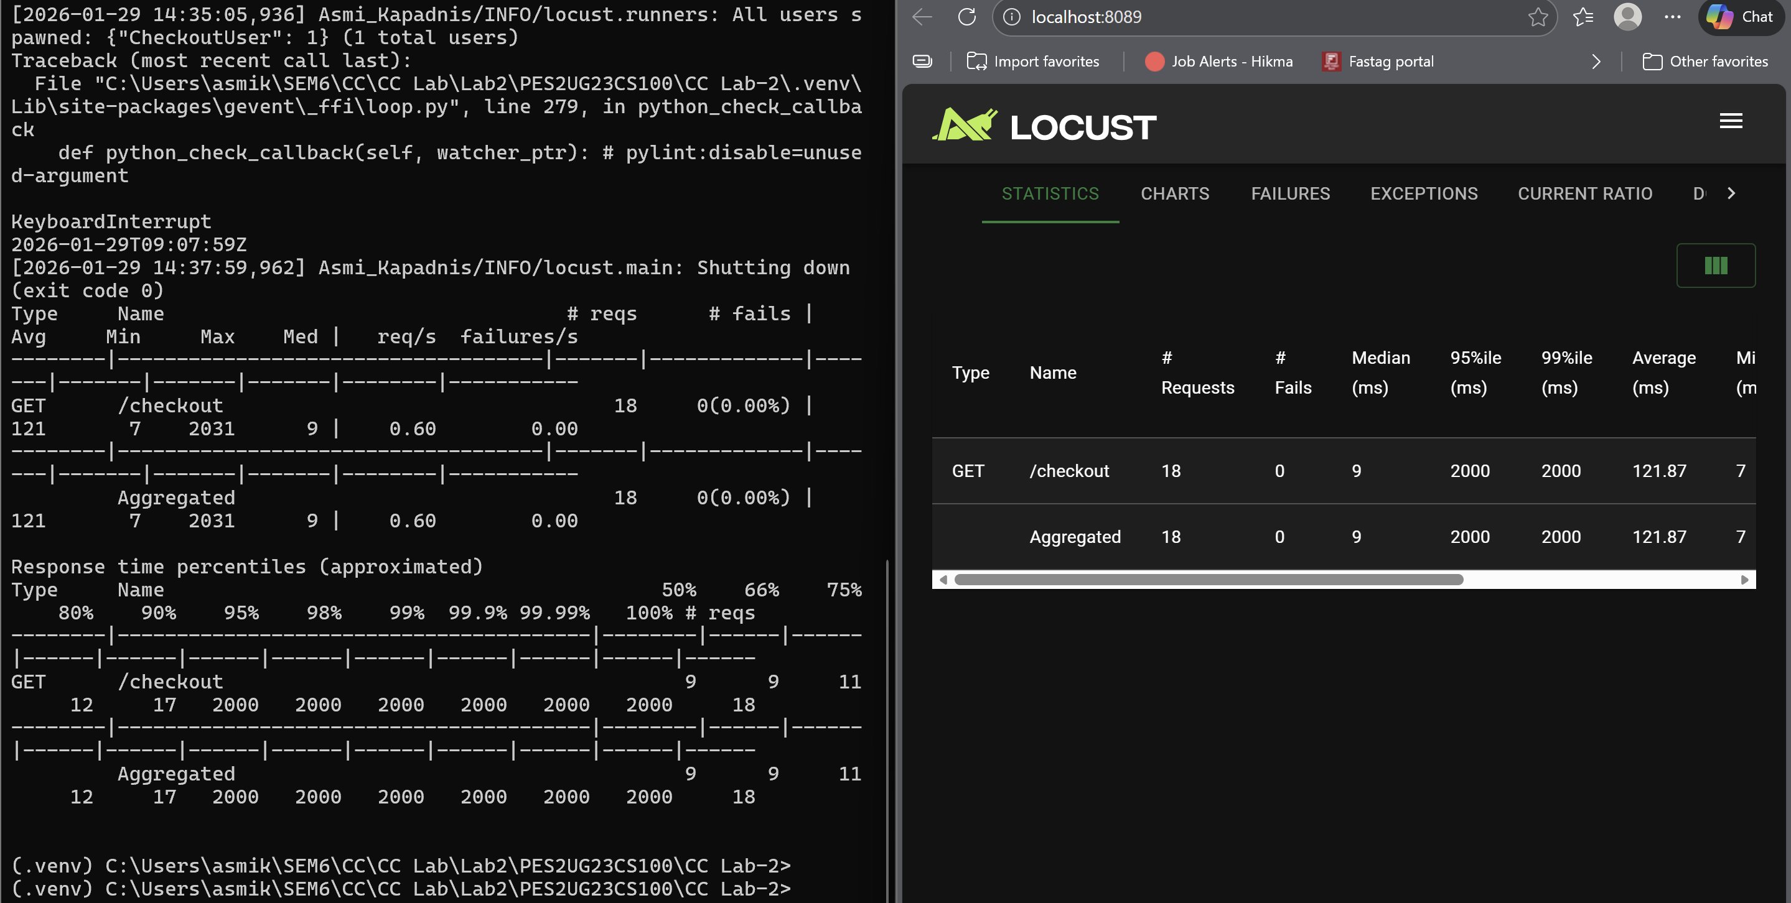

SS6:
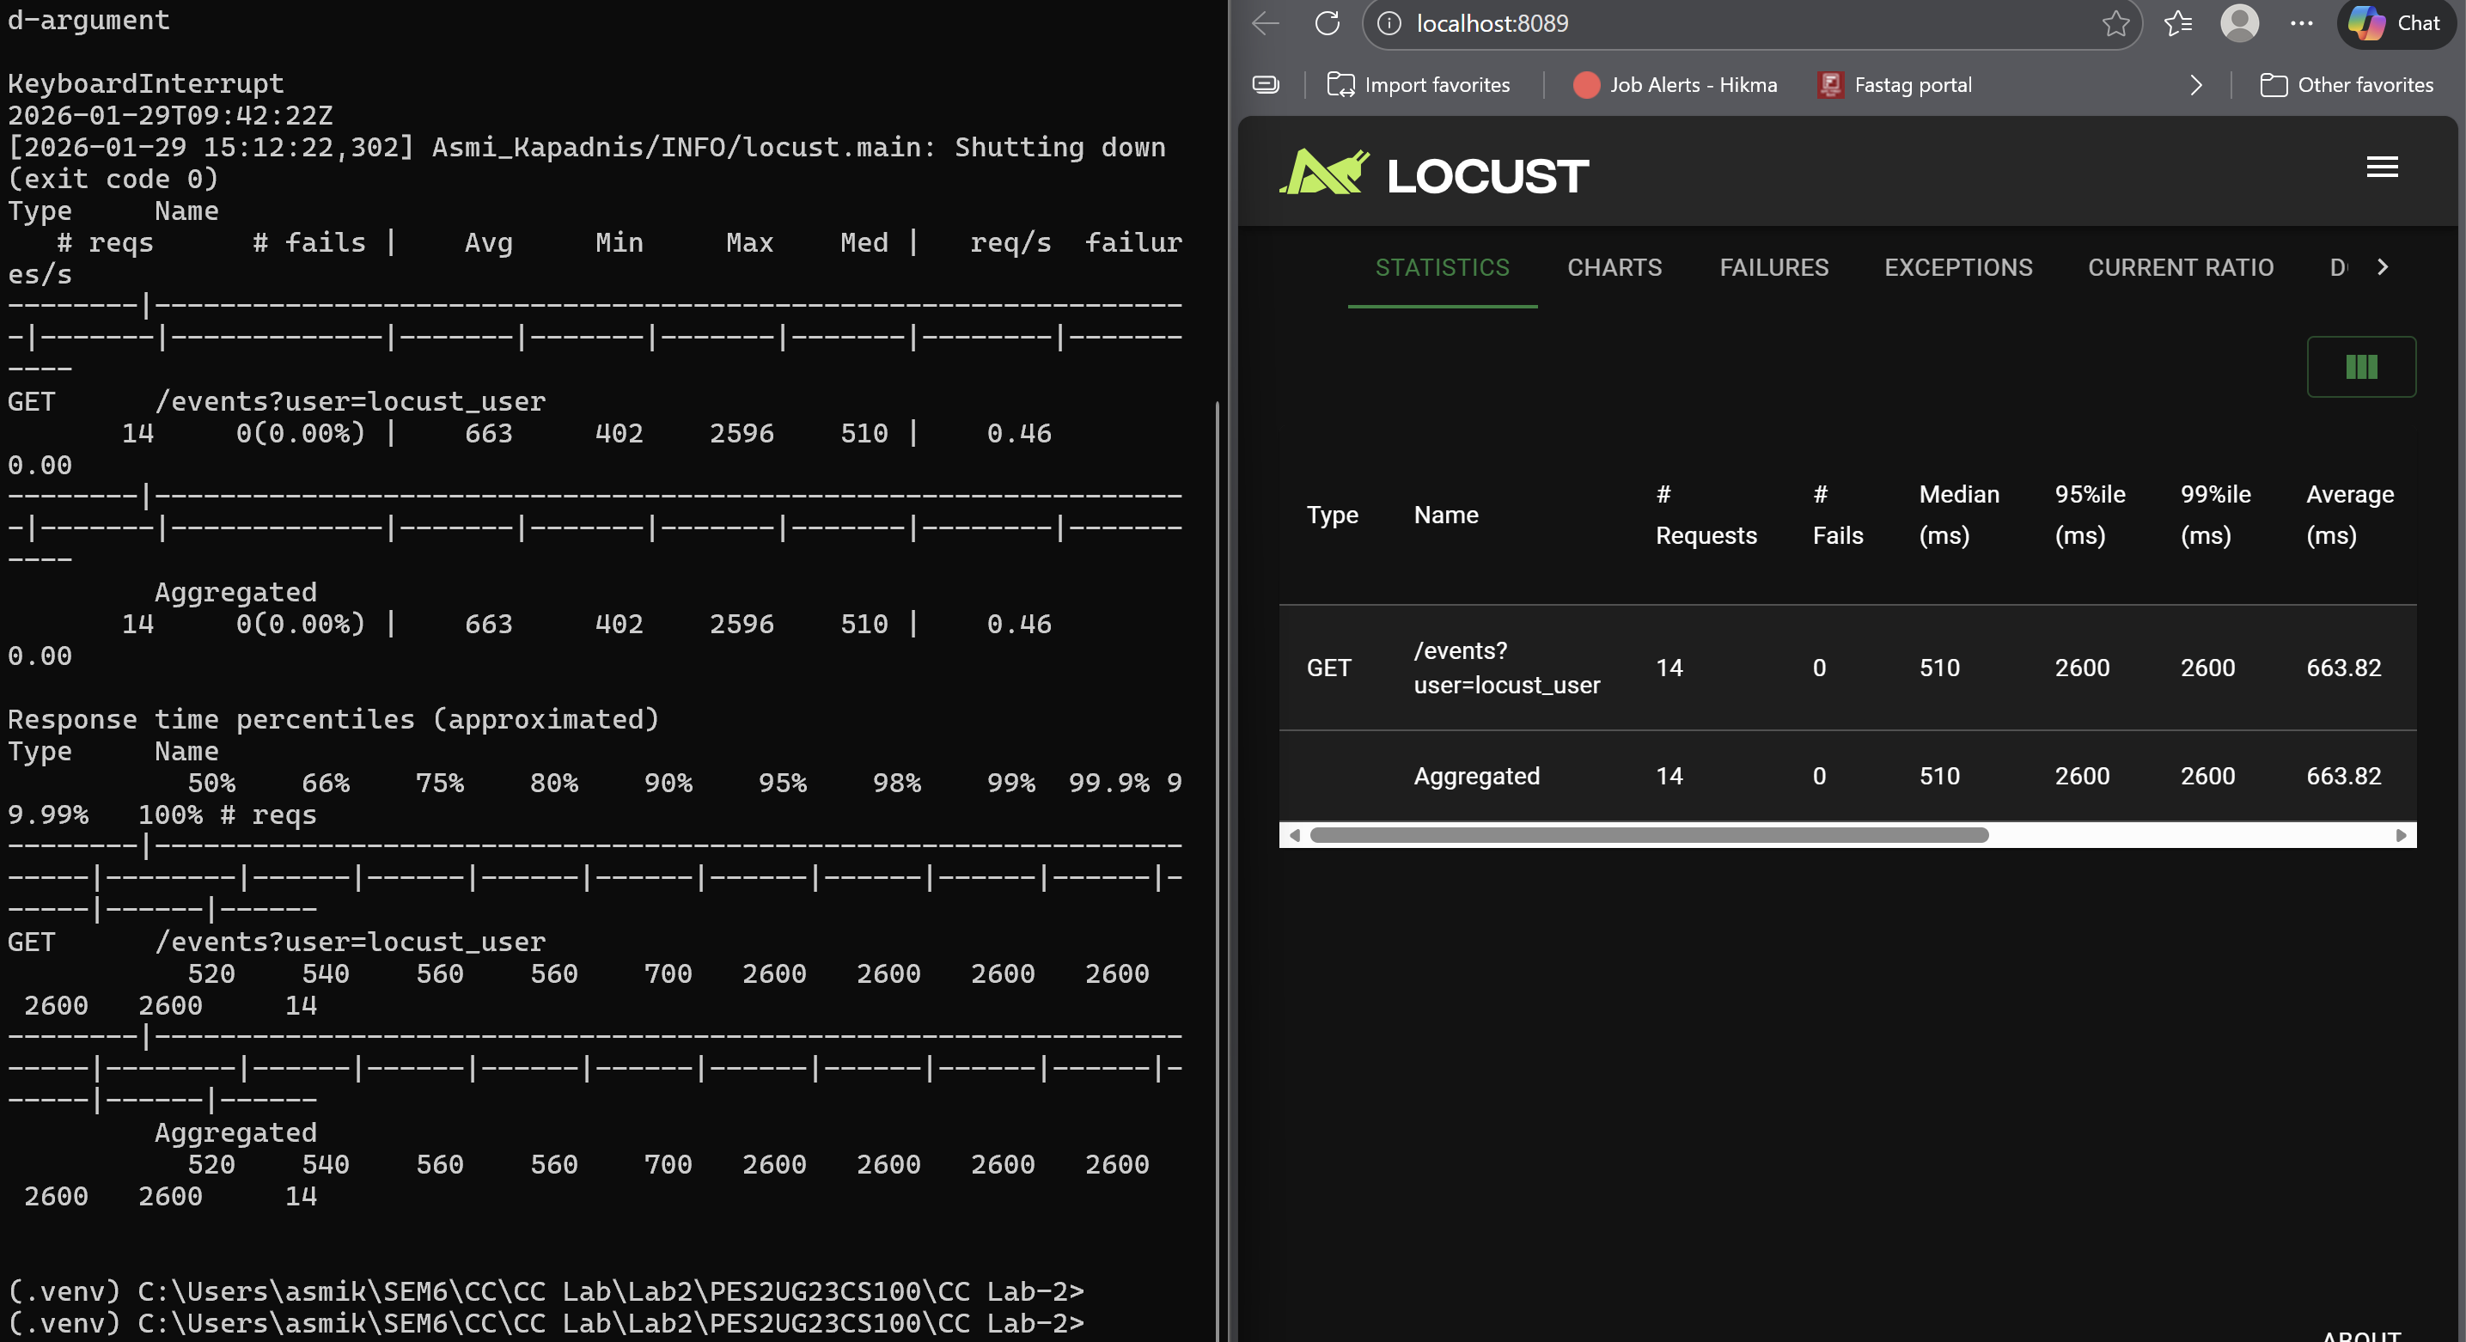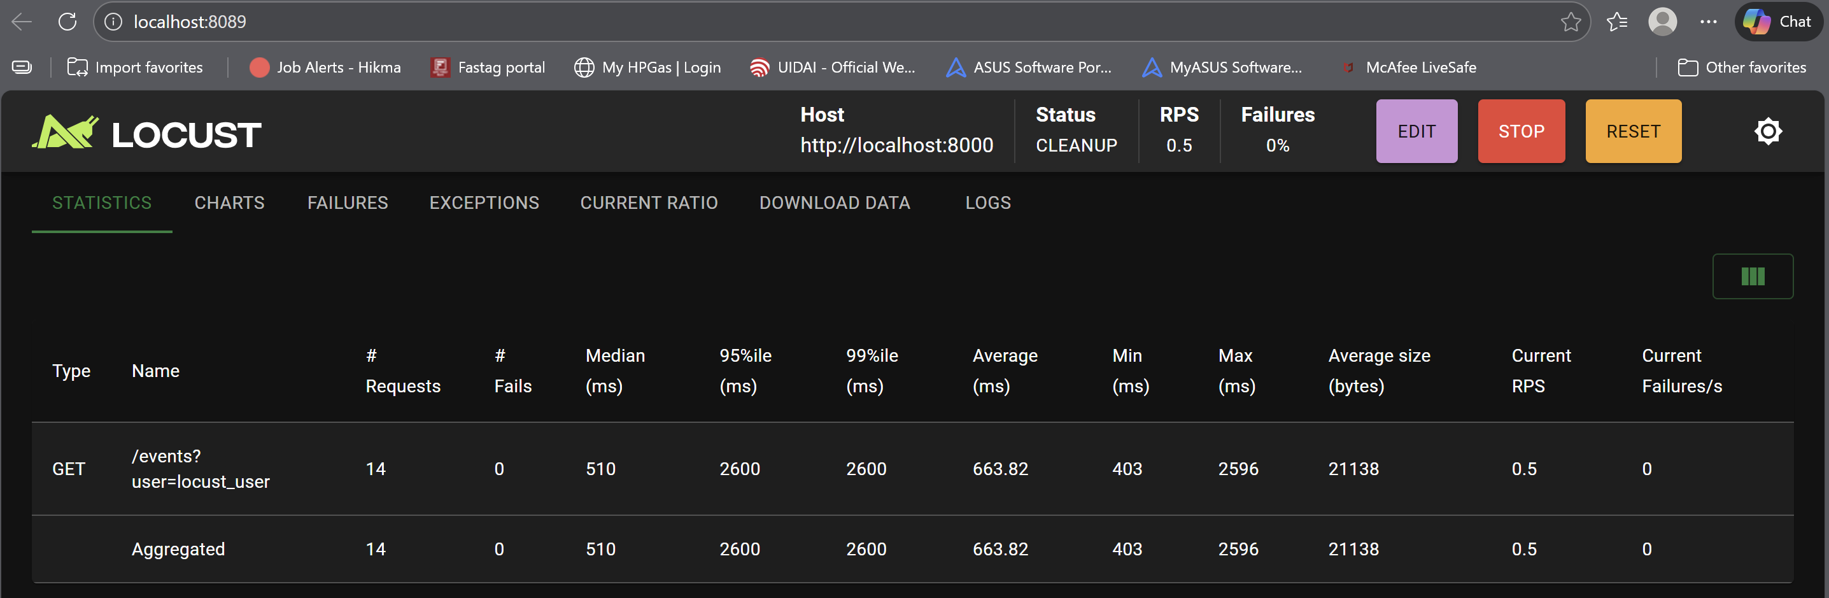

SS7:
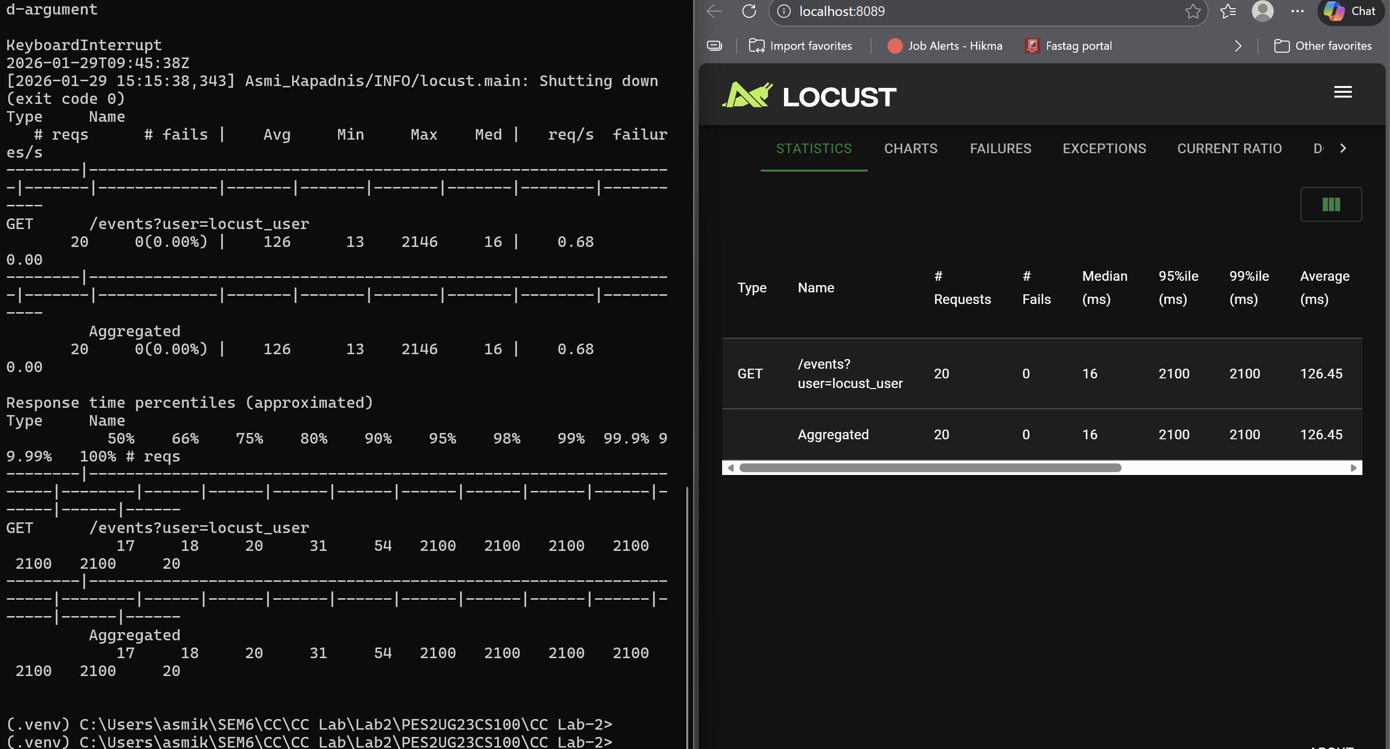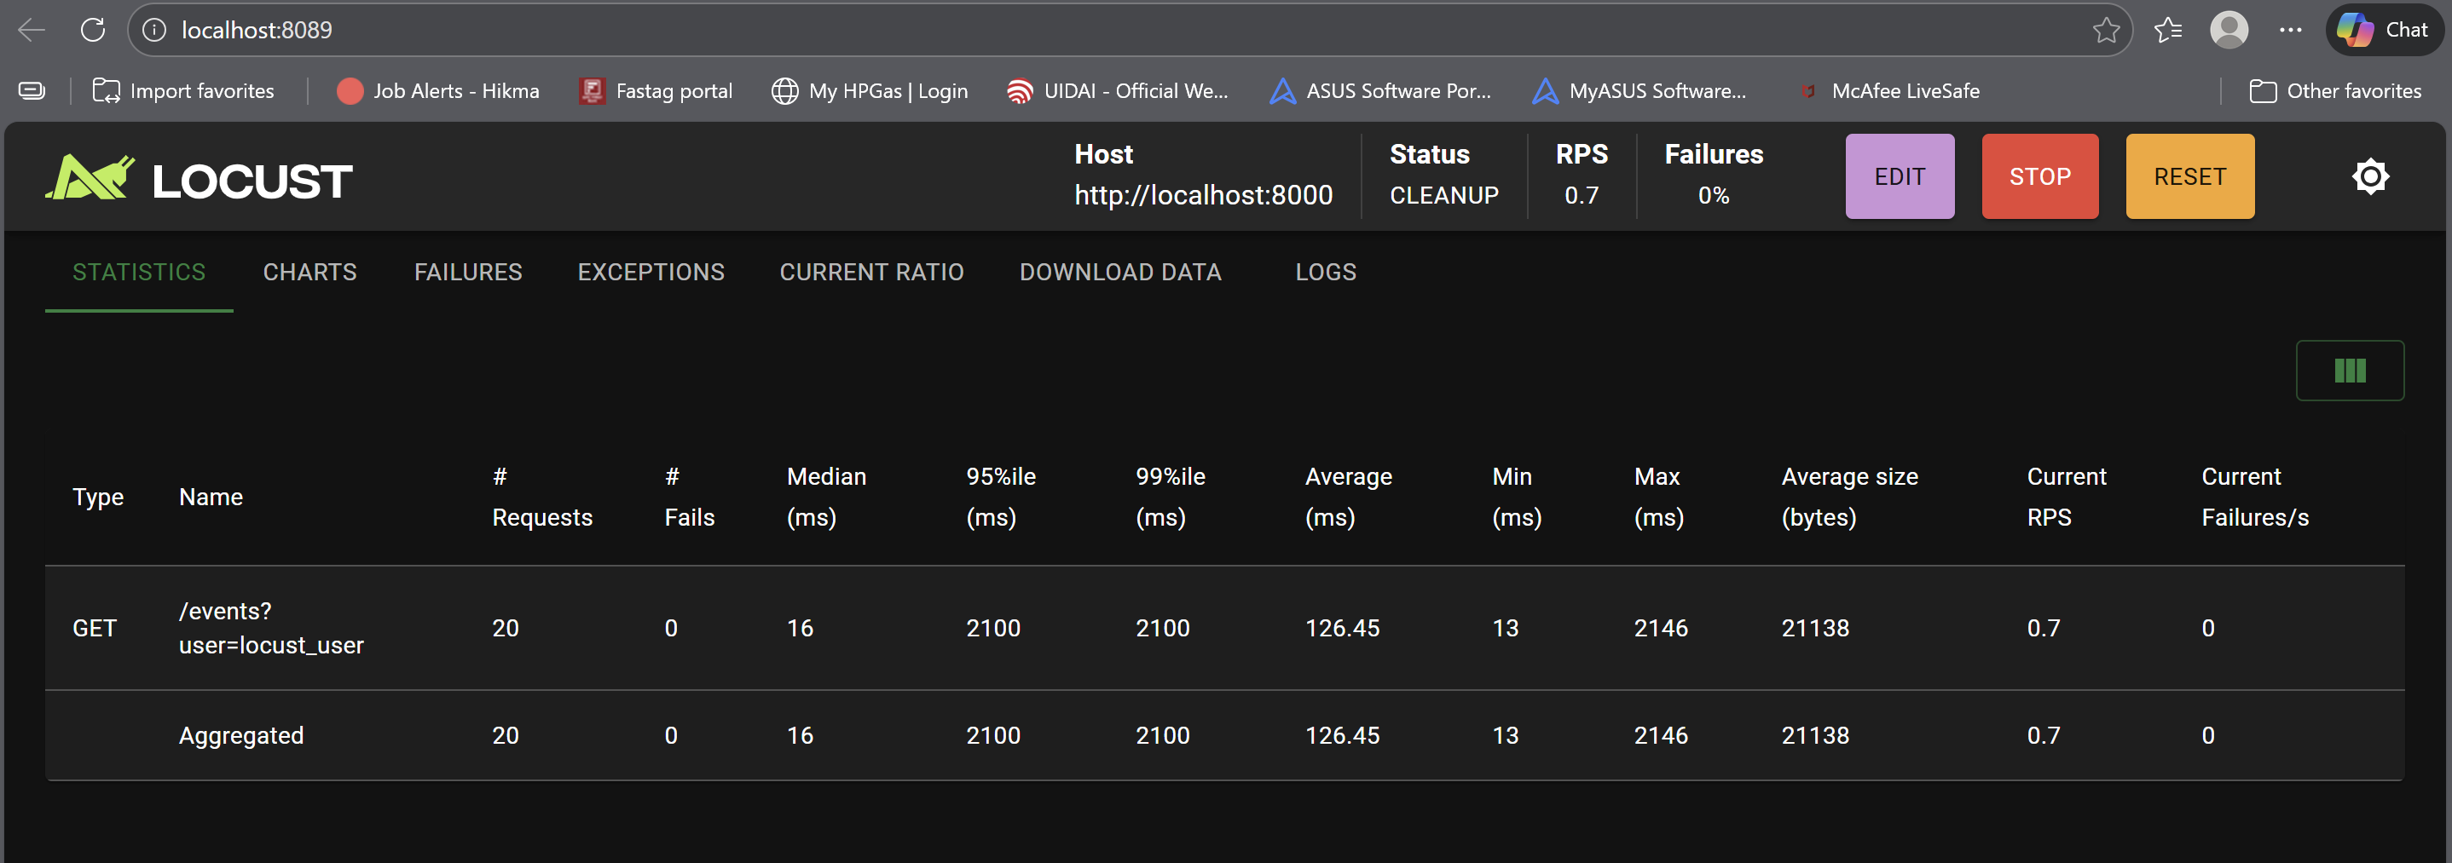

SS8:
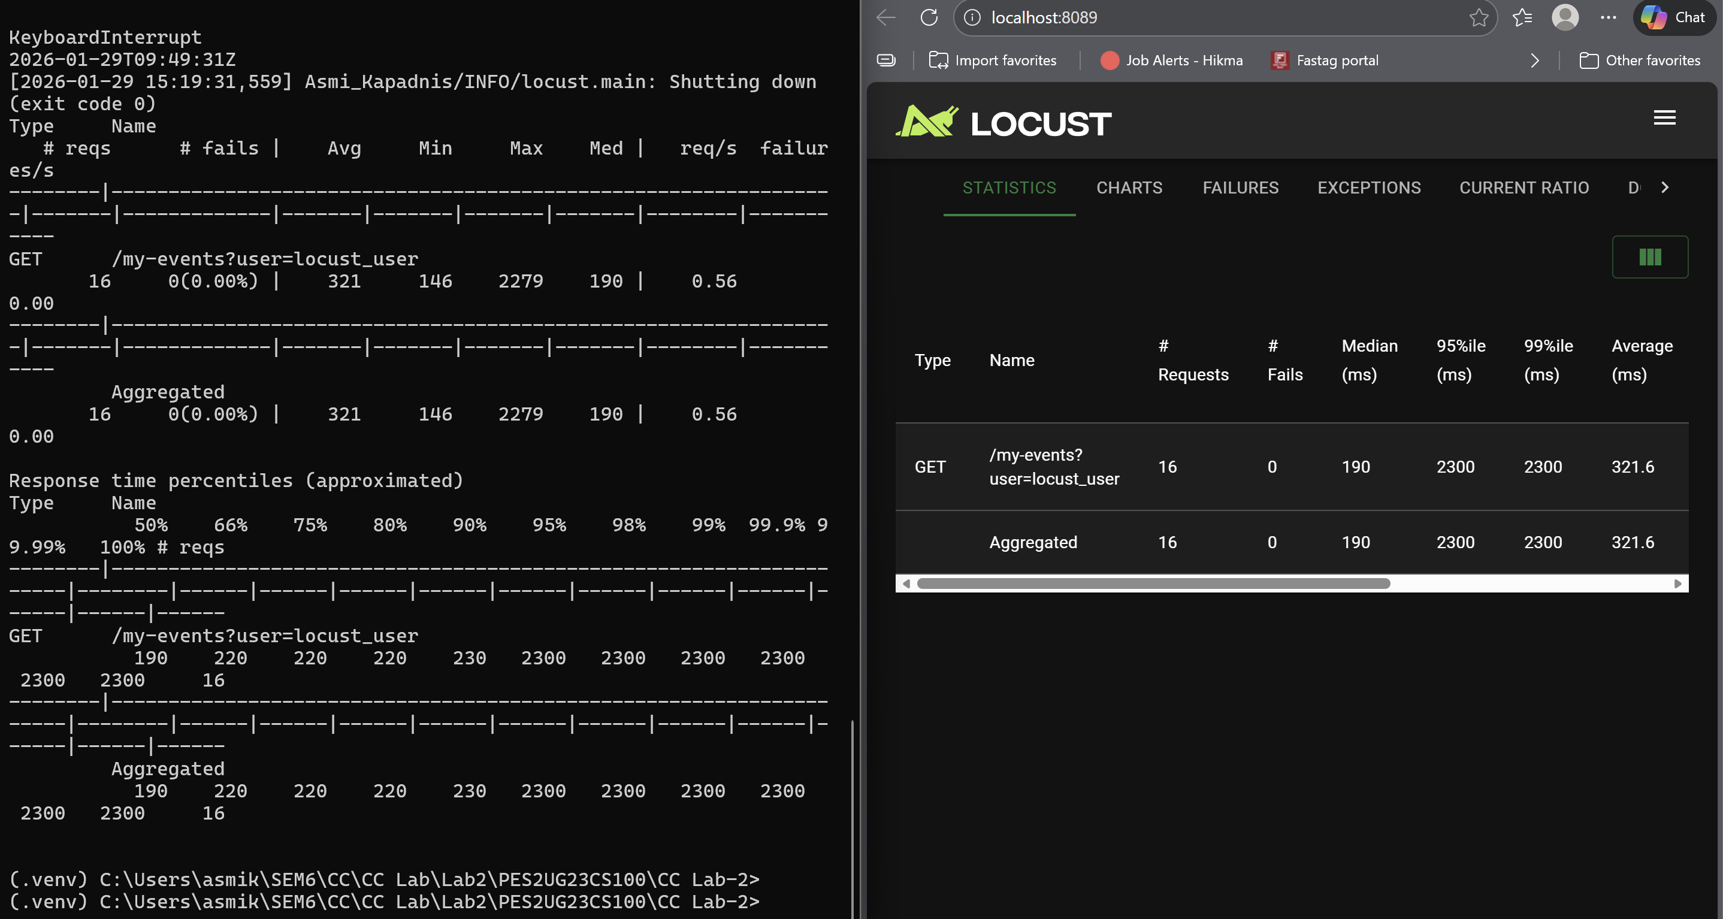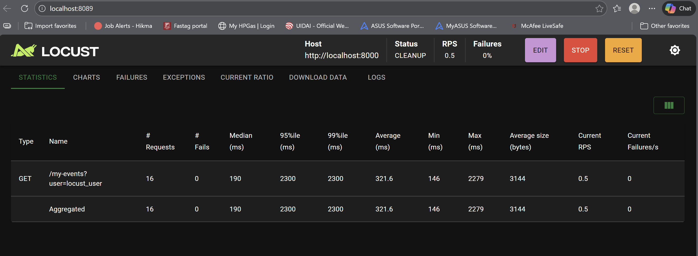

SS9:
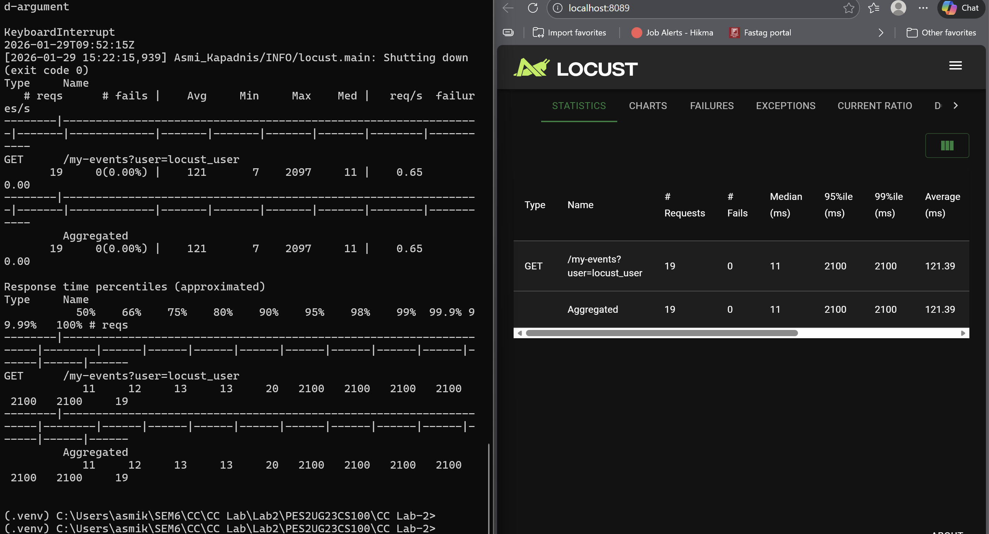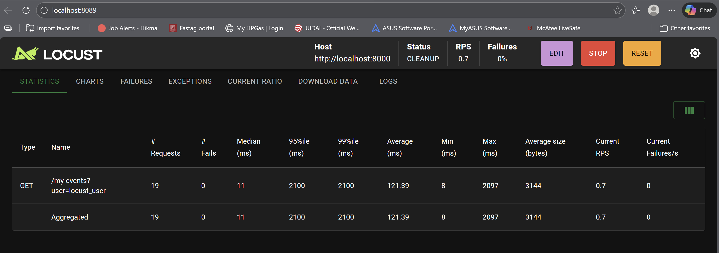

OPTIMIZATION EXPLANATION:
Route 1: /events
- What was the bottleneck? The route contained a high-iteration loop (3,000,000 cycles) that was performing unnecessary calculations. This created a CPU-bound bottleneck, where the processor was busy doing "busy work" instead of serving the user's request, leading to high latency.
What change did you make? I reduced the iteration count of the computational loop from 3,000,000 to 30,000 (a 100x reduction).
Original code (main.py):
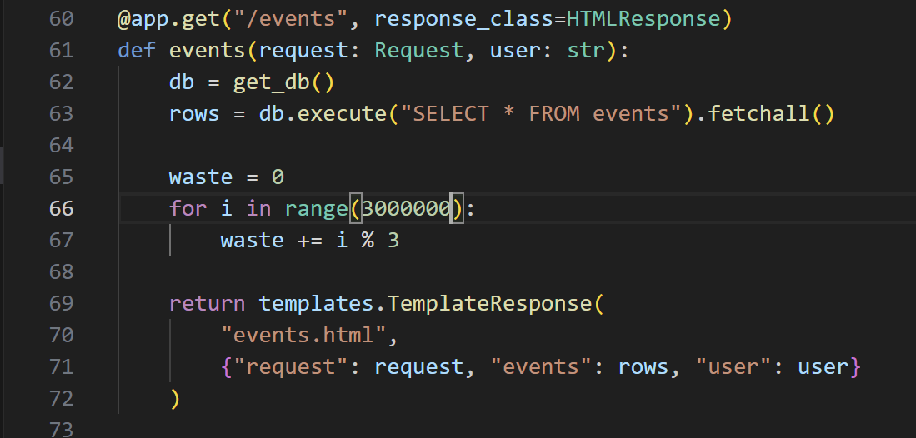
Optimized Code (main.py):
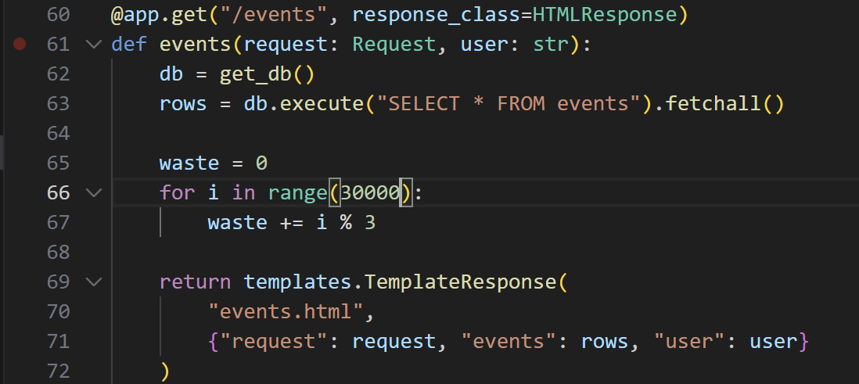
- Why did the performance improve? The time complexity remained O(n), but by significantly reducing the constant factor (n), the server spends much less time on the CPU per request. This allows the FastAPI event loop to handle more concurrent requests, decreasing the average response time.
Route 2: /my-events
- What was the bottleneck? There was a redundant "dummy" loop running for 1,500,000 iterations. In a monolithic architecture, such blocking code prevents the single process from handling other incoming traffic efficiently, causing a backup in the request queue.
- What change did you make? I optimized the logic by decreasing the loop iterations from 1,500,000 to 15,000.
Original Code (main.py):
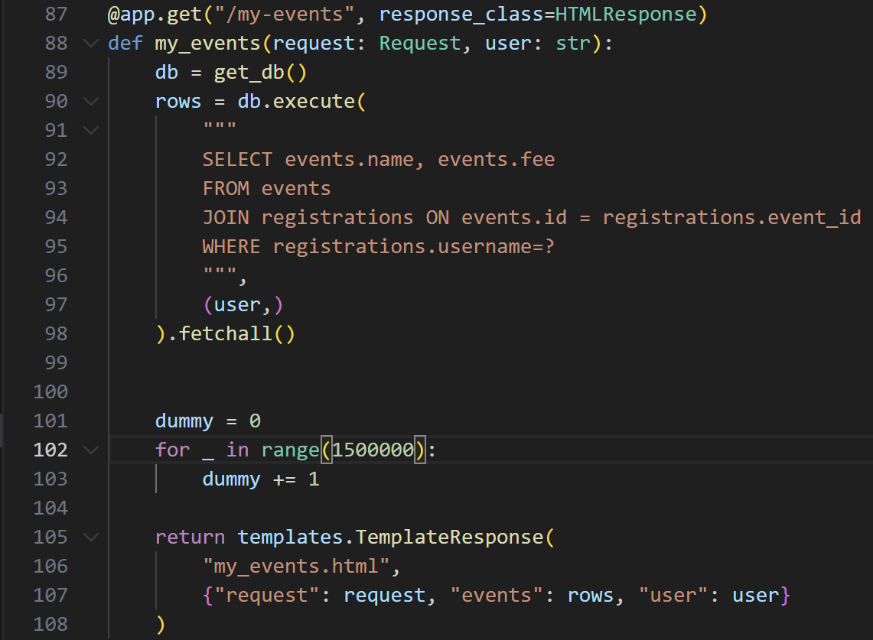
Optimized Code (main.py):
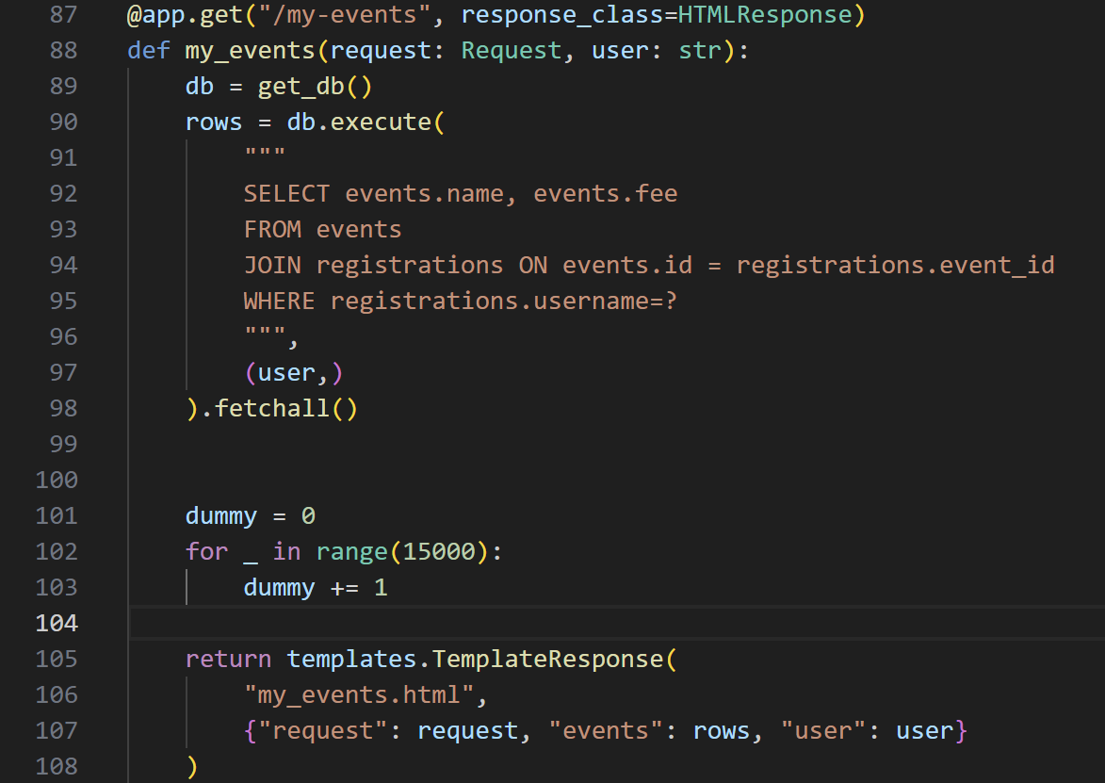
- Why did the performance improve? The reduction in iterations lowered the "execution time" of the function. This directly translates to a lower Average Response Time in Locust because the thread is freed up much faster to pick up the next task from the queue.

